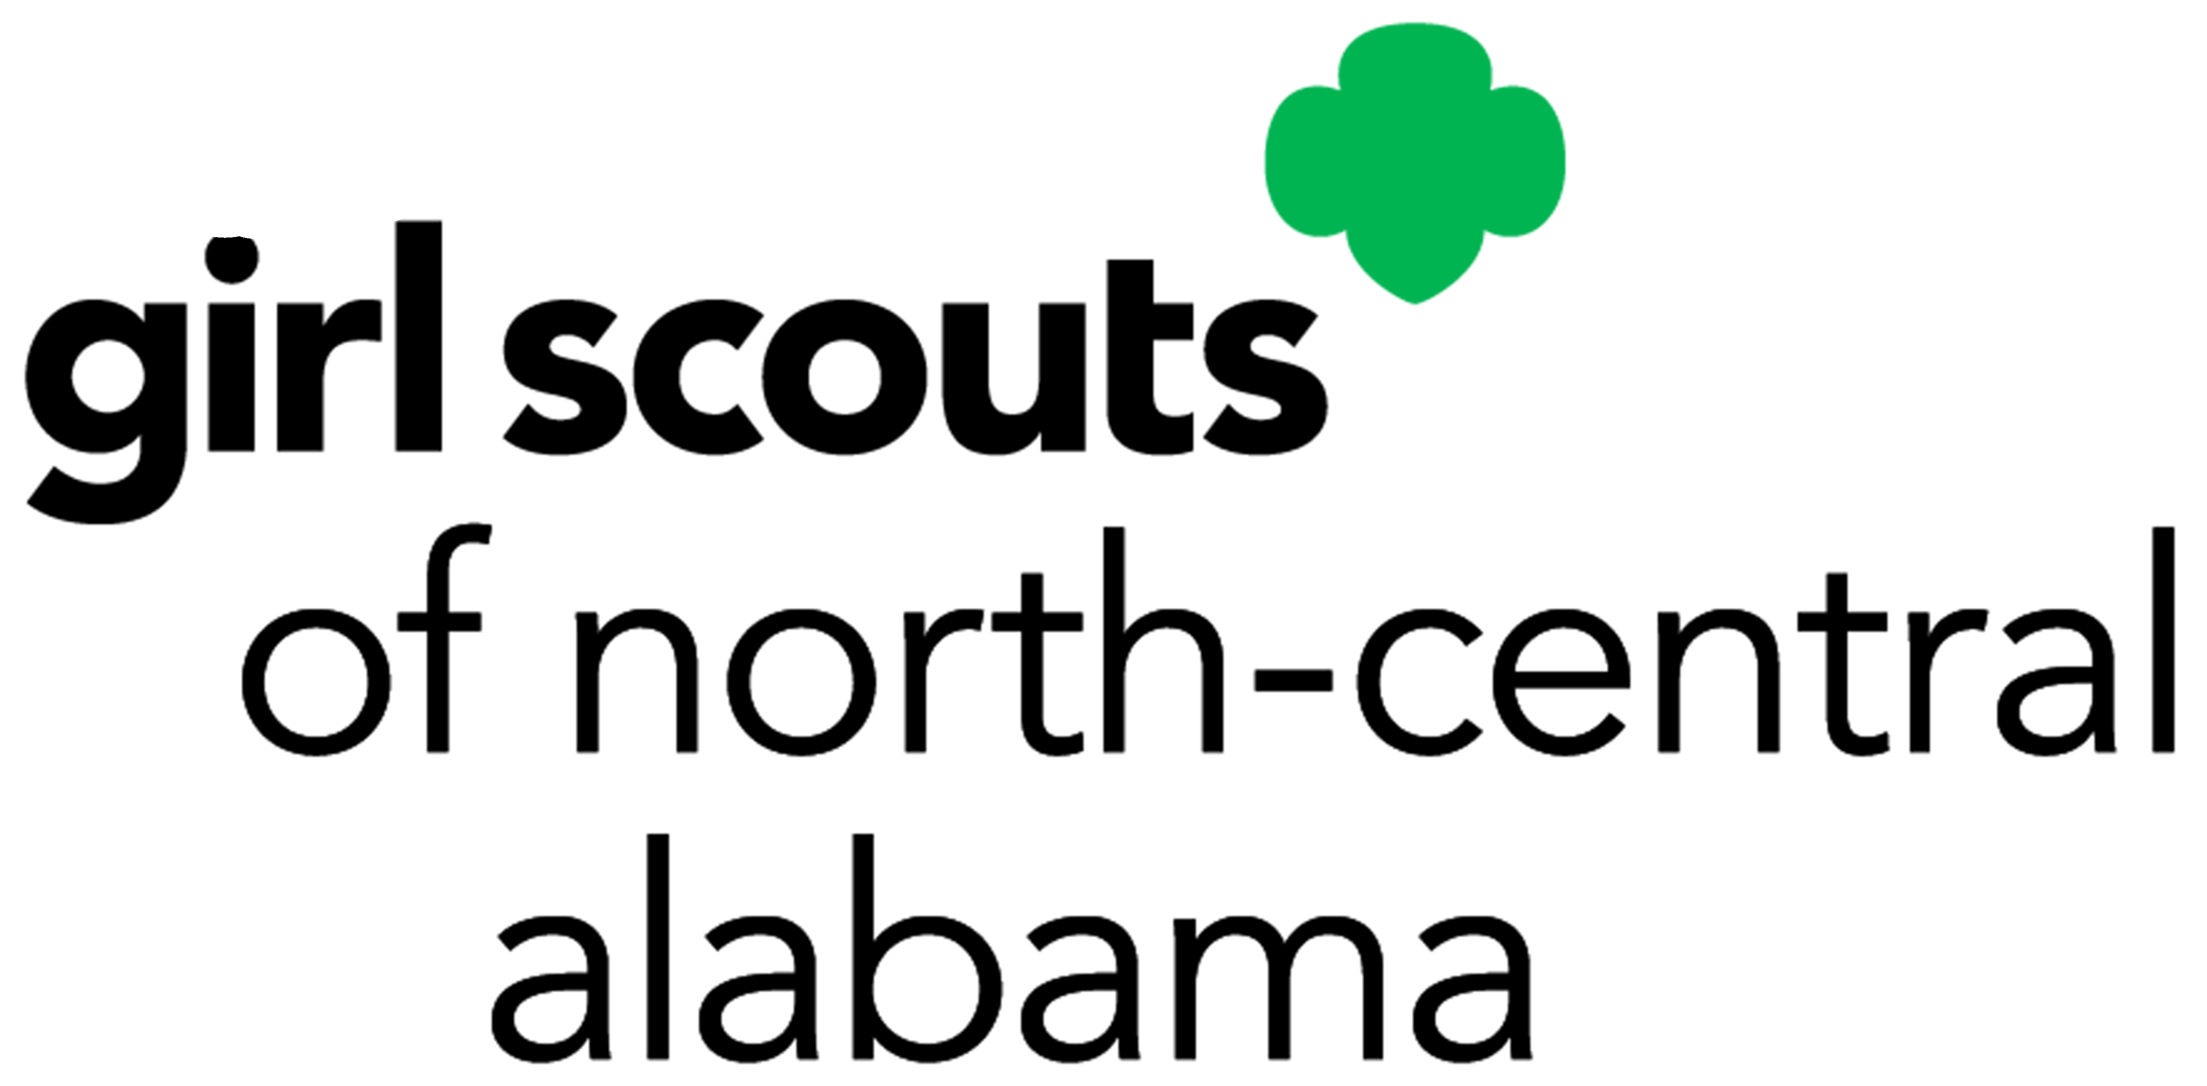
DATE(S): _____________________________________
PHOTOGRAPHER/PRODUCER: _____________________________________________
COUNCIL: Girl Scouts of North-Central Alabama
LOCATION: ________________________________________________________________________________
ACTIVITY: ________________________________________________________________________________
RECEIPT RELEASE FOR MINORS
I, being Parent/Guardian of ________________________________________________________________, hereby consent that her name, image, and likeness, as shown in the video-tapes, photographs, motion picture film and/or electronic images for which she posed, and/or audio recordings made of her voice may be used by Girl Scouts of the U.S.A. or Girl Scouts of North-Central Alabama, its assigns or successors, in whatever way they desire, including television; furthermore, I hereby consent that such photographs, films, recordings, electronic images, and the plates, tapes and/or software from which they are made shall be their sole property, and they shall have the right to sell, duplicate, reproduce and make other uses of such photographs, films, recordings, electronic images, plates, tapes and software as they may desire free and clear of any claim whatsoever on my part.
IN WITNESS WHEREOF I have hereunto set my hand, in the State of ___________________________, on this day ___________________________________________________________________________________________________________.
NAME OF MINOR: ________________________________________________________________________________________
SIGNATURE OF PARENT/GUARDIAN: _____________________________________________________________________
ADDRESS: ________________________________________________________________________________________________
CITY: _____________________________________________________ STATE: ________________ ZIP: __________________
RECEIPT RELEASE FOR ADULTS
I, being of legal age, hereby consent, that my name, image, and likeness, as shown in the videotapes, photographs, motion picture film and/or electronic images in which I appear, and/or audio recording made of my voice may be used by Girl Scouts of the U.S.A. or Girl Scouts of North-Central Alabama, its assigns or successors, in whatever way they desire, including television; furthermore, I hereby consent that such photographs, films, recordings, and electronic images and the plates, tapes and/or software from which they are made shall be their sole property, and they shall have the right to sell, duplicate, reproduce and make other uses of such photographs, films, recordings, electronic images, plates, tapes and software as they may desire free and clear of any claim whatsoever on my part.
IN WITNESS WHEREOF I have hereunto set my hand, in the State of ___________________________, on this day ___________________________________________________________________________________________________________.
NAME: ___________________________________________________________________________________________________
SIGNATURE: ______________________________________________________________________________________________
ADDRESS: ________________________________________________________________________________________________
CITY: ____________________________________________________ STATE: ________________ ZIP: __________________

